THE ROYAL SCOTTISH COUNTRY DANCE SOCIETY
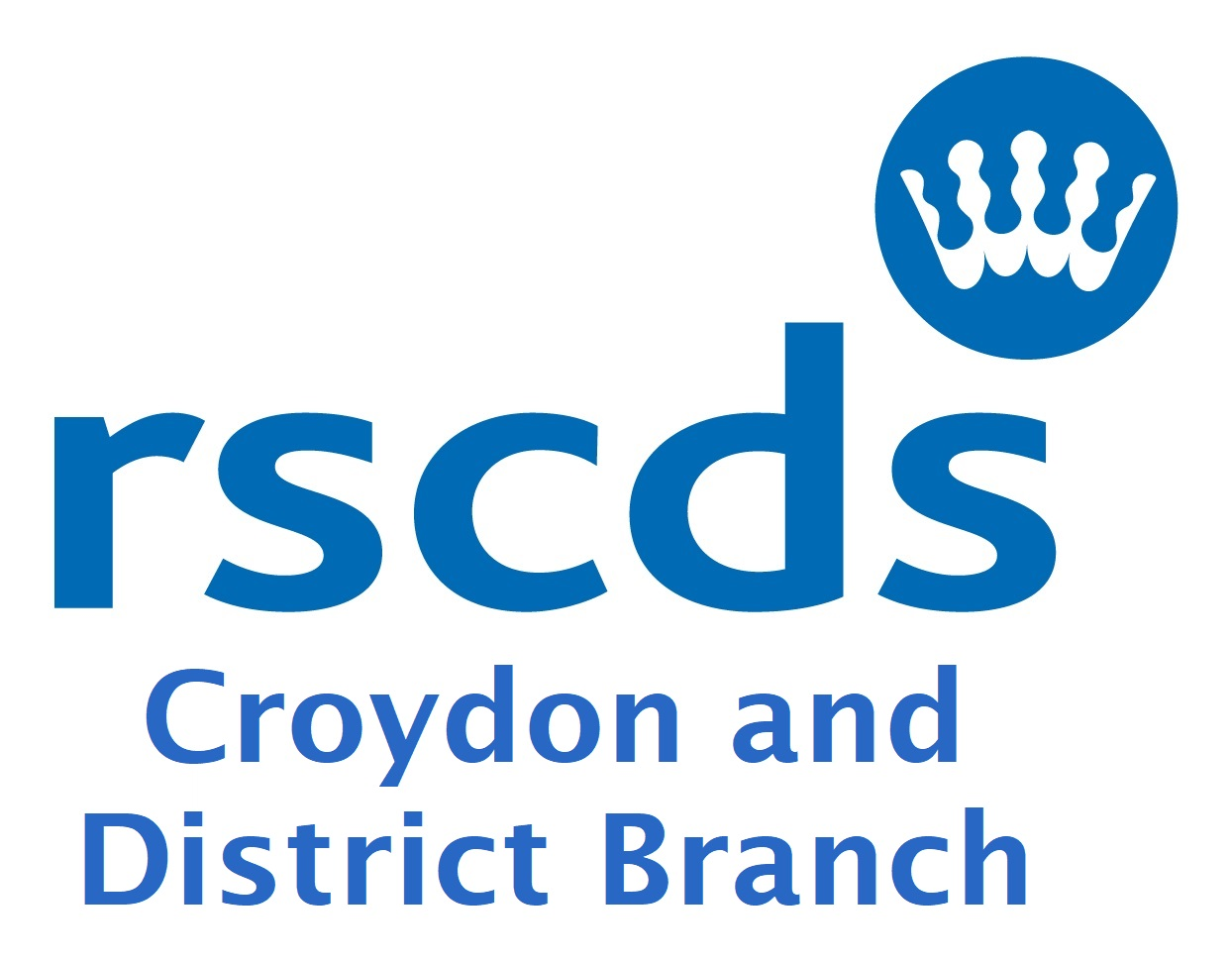
CROYDON AND DISTIRICT BRANCH
Registered Charity 1063364
COVID safety Guidelines Autumn 2023
We ask attendees to
  - keep up to date on any vaccinations offered
  - bring your own hand sanitiser and use on arrival and in between dances
  - leave if you feel at all unwell
  - please notify us if you test positive for Covid within 10 days of attending a Croydon Branch class/event
  - bring your own water/flask
- at the end of the evening take away from the premises any items you have brought with you, such as drink bottles and food wrappers
We will
  - keep a list of attendees and contact details via signing in forms or similar
  - limit numbers attending classes to a maximum of 50
  - keep halls ventilated
  - notify everyone promptly if a fellow attendee subsequently reports a positive Covid test
  - accept online/cheque/cash payment for classes for the term or cash per class
  - provide hand sanitiser in case people forget their own
  - at dances provide black sacks for clearing rubbish
We have tried to balance safety with freedom to dance but would be grateful for your support with the following additional constraints
Stay away if you
  - feel at all unwell or have members of your household showing signs of Covid
  - have had a positive lateral flow or PCR test

