THE ROYAL SCOTTISH COUNTRY DANCE SOCIETY
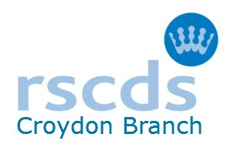
CROYDON AND DISTIRICT BRANCH
Registered Charity 1063364
Return to classes and Social Dancing - COVID safety Guidelines
We ask attendees to
  - keep up to date on any vaccinations offered
  - ideally, take a lateral flow test before coming
  - bring your own hand sanitiser and use on arrival and in between dances
  - wear a face covering over your nose and mouth (unless exempt)
  - maintain social distancing when not dancing
  - indicate to other dancers if you do not wish to take hands
  - be mindful of your own level of fitness
  - leave if you feel at all unwell
  - notify us if you test positive for Covid within 10 days of attending a Croydon Branch class/event
  - bring your own water/flask
- at the end of the evening take away from the premises any items you have brought with you, such as drink bottles, and at dances, food wrappers
We will
  - keep a list of attendees and contact details via signing in forms or similar
  - display test and trace QR codes where appropriate
  - keep halls ventilated
  - arrange chairs around the hall with distance between, attendees are requested not to move the furniture
  - notify everyone promptly if a fellow attendee subsequently reports a positive Covid test
  - accept online/cheque payment for classes for the term or cash per class
  - provide hand sanitiser in case people forget their own
  - at dances provide black sacks for clearing rubbish
We have tried to balance safety with freedom to dance but would be grateful for your support with the following additional constraints
Stay away if you
  - feel at all unwell or have members of your household showing signs of Covid
  - have had a positive lateral flow or PCR test
  - are subject to a legal requirement to quarantine or isolate
Food
  - no food during classes
  - bring your own refreshments for dances, no sharing please
  - we will provide drinks at dances in disposable cups but ask that only designated people enter the kitchen

